1. Install CentOS /RHEL

* *Done*

1. What is the difference between cat and more command?

|  |  |
| --- | --- |
| *Cat* | *More* |
| *Concatenate files and print on the standard output*  *Show Entire Content In One Shot and Scrolling if content large* | *Display the contents of a file in a terminal*  *Show Content In page suitable to screen and can user show more by ‘space’ keyboard* |

1. What is the difference between rm and rmdir using man?

|  |  |
| --- | --- |
| *rm* | *rmdir* |
| *Remove files or directory* | *Remove empty directories* |

1. Create the following hierarchy under your home directory:

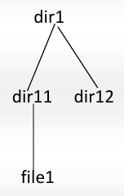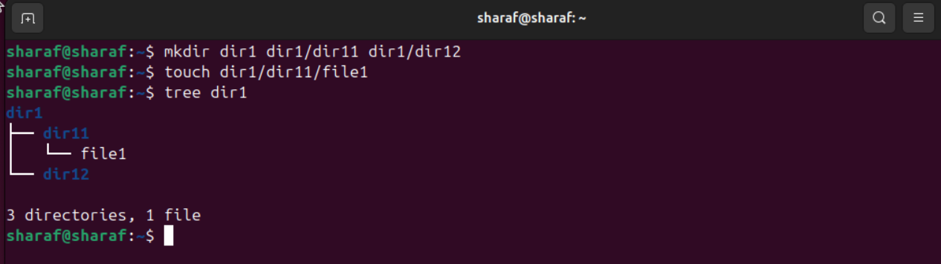

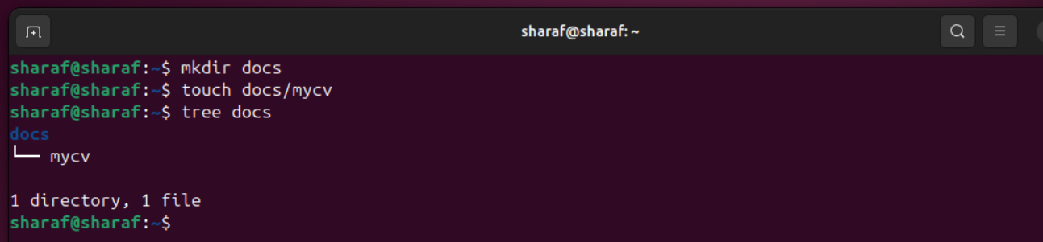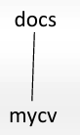

1. Remove dir11 in one-step. What did you notice? And how did you overcome that?



* *To Overcome ( use –r )*



1. Then remove dir12 using rmdir –p command. State what happened to the hierarchy (Note: you are in your home directory).



* *Dir12 -> Deleted Because it’s empty*
* *Dir1 -> Can’t Deleted Because it’s not empty*

1. The output of the command pwd was /home/user. Write the absolute and relative path for the file mycv

|  |  |
| --- | --- |
| *Absolute Path* | */home/Sharaf/docs/mycv* |
| *Relative Path* | *docs/mycv* |

1. Copy the /etc/passwd file to your home directory making its name is mypasswd.



1. Rename this new file to be oldpasswd.



1. You are in /usr/bin, list four ways to go to your home directory
2. 
3. 
4. 
5. 
6. List Linux commands in /usr/bin that start with letter w



1. Display the first 4 lines of /etc/passwd

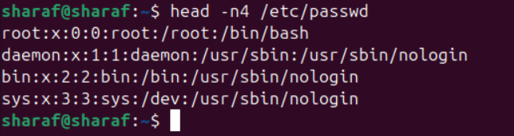

1. Display the last 7 lines of /etc/passwd

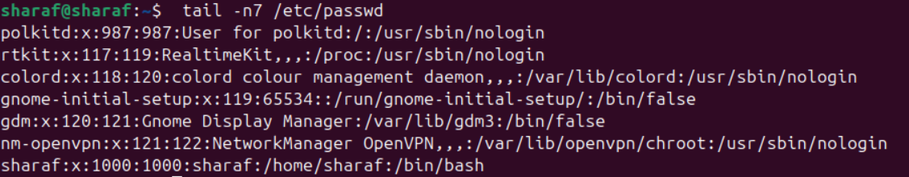

1. Display the man pages of passwd the command and the file sequentially in one command.

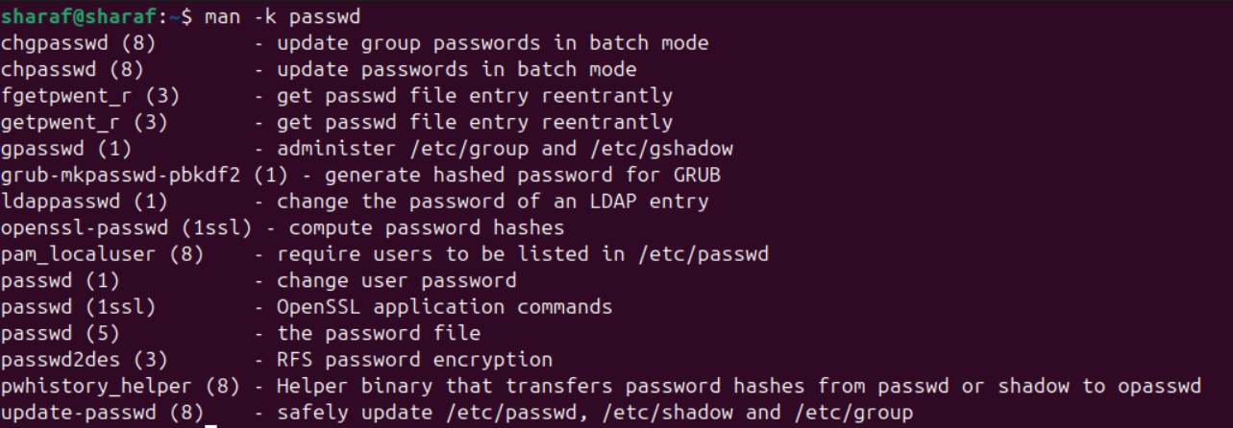



1. Display the man page of the passwd file.



1. Display a list of all the commands that contain the keyword passwd in their man page.

